Course Description
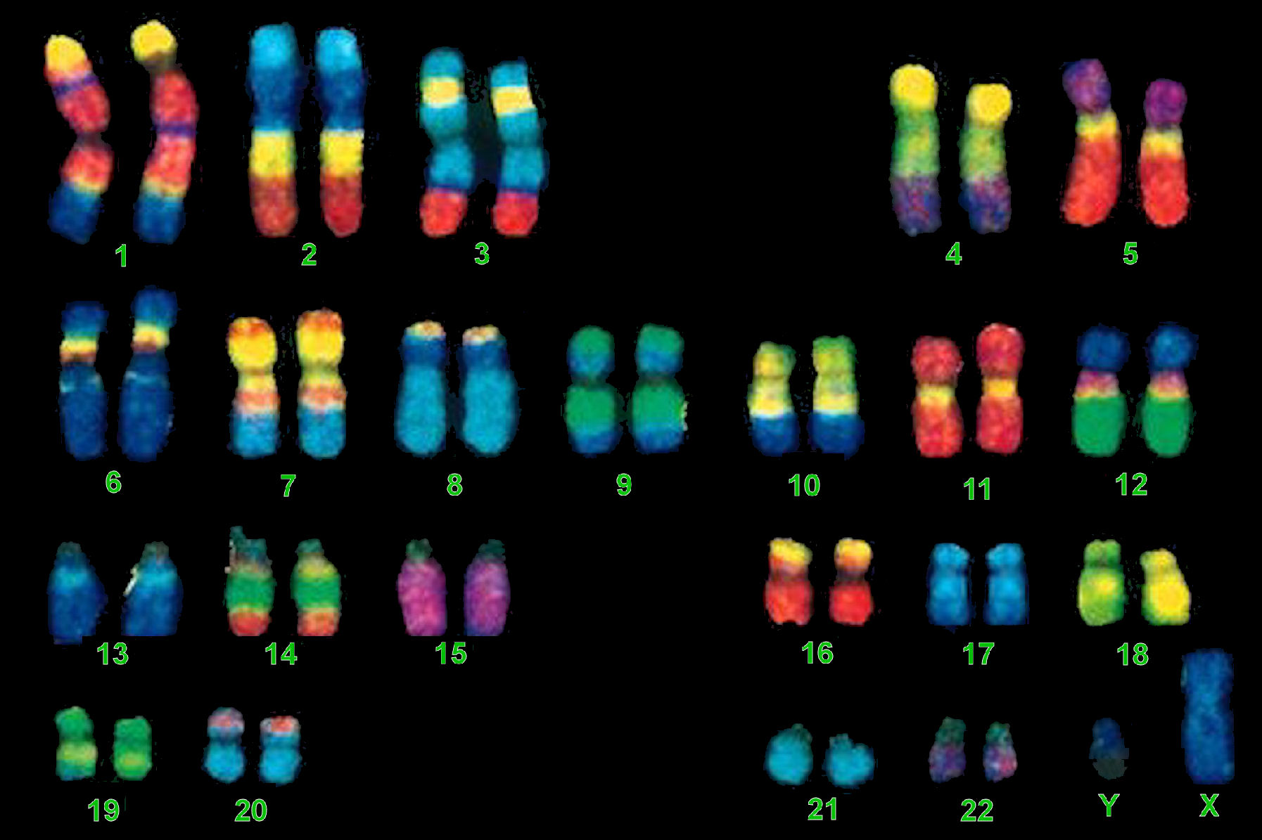
This course is designed to provide an introduction to the world of medical genetics. My hope is that students will achieve an understanding of basic human genetic principals through the examination of various genetic diseases. We will discuss the chromosomal basis of heredity, the structure and function of genes and proteins, and the mechanisms of DNA mutation with an emphasis on the molecular pathology of disease.
Instructor: Mallary Hoidal
Graduate student
Molecular and Cell Biology
Brandeis University
Waltham, MA 02451
(781) 864-2341
mjhoidal@brandeis.edu

Class Schedule Day 1 Introduction to human genetics

Day 2 Cancer

Day 3 Autosomal dominant disorders

Day 4 Autosomal recessive disorders

Day 5 Sex-linked diseases

Day 6 Aneuploidy

Day 7 Chromosomal rearrangements

