THE CHAOS GAME
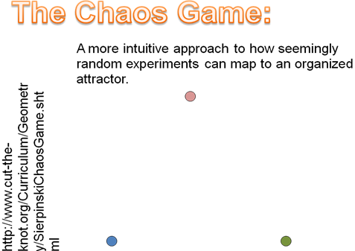
The procedure of the chaos game is as follows:
Given three points arrayed as those to the right,
- Select a random location on the page to begin (anywhere inside or outside or on the triangle). Call this point P₁.
- Choose one of the red, blue, or green points at random.
- Consider the line between the chosen triangle vertex and P₁ and mark the point halfway along the line between them. Call this point P₂
- Choose one of the red, blue, or green points at random.
- Consider the line between the chosen triangle vertex and P₂ and mark the point halfway along the line between them. Call this point P₃
- Continue this iterative procedure indefinitely.
To see an online demo of this (because plotting “indefinitely many” points is ridiculous) see the website: http://www.cut-the-knot.org/Curriculum/Geometry/SierpinskiChaosGame.shtml (WARNING – This website may be mesmerizing)
Assignment:
Deduce a mathematically rigorous explanation of the chaos game – why does the procedure result in the creation of the Sierpinski triangle? How would you create, using a similar method, the Sierpinski carpet? How about a fractal Fern?
If you want a hint, or some practice, use the applet at:
http://math.bu.edu/DYSYS/applets/
Try to figure out the answer without the hint website, but, even if you can, take a look at the website afterward as that is where we will start in class on Saturday. If you have any questions about the assignment or your answer (even if you're not in the HSSP class) feel free to e-mail me at ch3cooh@mit.edu.
See you Saturday!
-- Zandra Vinegar

