'Rugby For All'

Young Athletes, Simple Rules and the Right Tools = FUN!


USA Rugby is proud to offer Rugby for All as our nation’s development pathway for players, coaches and referees. Included in the program is everything from where to start to the many different options for continued participation - there truly is a place for all!
Providing a roadmap to follow makes any variation of rugby simple to get started, easy to organize and fun to learn for everyone who becomes involved.
Ready to go? Scroll to find where you fit in the continuum now!

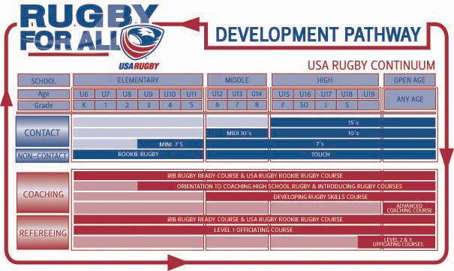

Finding a club near you:
- Go to usarugby.com
- In the column on the left side, click on ‘Find A Club’
- Fill in State, and League (youth or high school)
- Contact the one nearest you and…
- RUCK!!!
- You can explore the site for more rugby goodness

